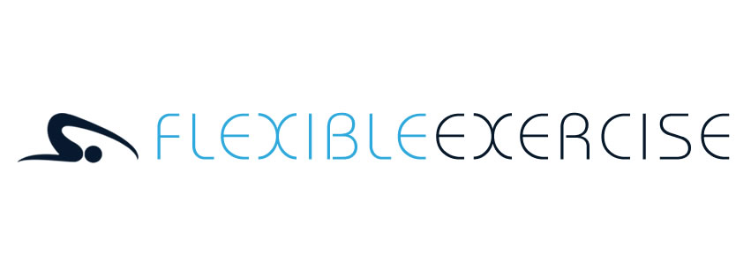
Terms and Conditions
These terms and conditions are applicable to everyone in all circumstances, thank you for your understanding.
Confidentiality
All information you provide will be kept in confidence in accordance with the General Data Protection Regulation (GDPR) 2018. Your personal details and medical information will be used for teaching purposes and will not be made available to third parties unless permission to do so is granted by you and under no circumstances will personal information be sold to third parties. You can opt out of receiving emails or other communication from us at any time by emailing us. We will then remove you from our mailing list.
Recommendations & Referrals
Using judgement and experience, certain exercises and other advice may be suggested to help you achieve your personal goals, specific requests can be discussed directly.
If you have any problems, concerns or complaints please contact me as soon as possible.
When I believe it is in your best interests to see a medical professional, I will refer you appropriately.
Cancellations or changes
If I cancel or run late the following policy will apply:
If I am unable to teach your session I will contact you at the earliest opportunity, by text message, email or phone. Any outstanding payment will be rolled forward to the next session.
If I run late in starting a session I will extend the session time accordingly or make it up at a future date.
If a venue is unavailable, I will relocate the session to an alternative venue wherever possible.
Use of equipment
I will provide a limited supply of spare equipment and mats for use at sessions, on a first come, first serve basis. For hygiene and comfort reasons many people like to bring their own mat to class.
Disclosure of information & accepting potential risks
You will disclose all health information as requested on the client enrolment form. You will keep me updated and informed of any changes to your health status and you agree to sign the informed consent as part of the registration process. If necessary, you may need to seek clearance from a medical professional before participation in a session. Whilst for most people Pilates is hugely positive with many health benefits, there remains some risk and you are responsible for your own risk.
Terms and conditions specific to group classes
Prior booking for classes is essential.
Once you are enrolled, classes are run as a block of weeks on a rolling arrangement.
Payments for blocks can be made by bank transfer, cash or cheque before the start of a block booking period.
Your space at a class is only secure once payment has been received (we are unable to hold places with payment).
If you are going to be absent from your class please let me know giving as much notice as possible. This is as a courtesy to others wishing to make use of the make-up policy (see below).
I offer a courtesy make-up class policy which means that if you are absent e.g. due to illness, holiday etc you can come along to another class at another venue and make that class up. You can even make up a class in advance of being absent.
To make use of the make-up class policy you will need to let me know in advance that you want to come along and make up so that I can check a space will be available
It is not possible to carry over classes missed into the next block of classes
As an alternative to the make up policy, it is possible to nominate someone who isn’t currently a group member to take your place at a class on a prearranged basis with Flexible Exercise, subject to them satisfactorily completing with enrolment form.
I require a minimum of 4 weeks notice if you no longer require your space in a class and I reserve the right to charge for a full block unless this notice period is observed.
Terms and conditions specific to private tuition and massage
Packages and individual sessions are payable in full at the first session.
Payments can be made by bank transfer, cash or cheque before or at the start of the session.
In the event that you need to reschedule or are running late for a session, please contact by texting or calling and leaving a message on 07752 587600.
• Cancelling with less than 24 hours’ notice, or if you fail to show you will be required to pay 100% of the session fee.
• If you are late to a session, I will do my best to get the most out of the remaining time left of the session.
Fees and pricing
Information relating to pricing and availability is subject to change without notice.
All payments are non-refundable and non-exchangeable.
General
Terms and conditions may be changed periodically.
By browsing this site, social media platforms and/ or booking a session you are agreeing to the terms and conditions. These terms and conditions supersede any previous agreements.

